John Kiyak

CS 355

Homework 9

*A network provider investigates the load of its network. The number of concurrent users is recorded at fifty locations in thousands of connected users.*

*17.2 22.1 18.5 17.2 18.6 14.8 21.7 15.8 16.3 22.8*

*24.1 13.3 16.2 17.5 19.0 23.9 14.8 22.2 21.7 20.7*

*13.5 15.8 13.1 16.1 21.9 23.9 19.3 12.0 19.9 19.4*

*15.4 16.7 19.5 16.2 16.9 17.1 20.2 13.4 19.8 17.7*

*19.7 18.7 17.6 15.9 15.2 17.1 15.0 18.8 21.6 11.9*

*Compute:*

*Sample mean*

*Variance*

*Standard deviation*

*Median*

*Five point summary*

*Interquartile range*

*Print a histogram of values with intervals of .5.*

*Does the histogram appear to be Normal? Skewed left? Skewed right? Bimodal?*

*Are there any outliers?*

*17.2, 22.1, 18.5, 17.2, 18.6, 14.8 ,21.7 ,15.8, 16.3, 22.8, 24.1 ,13.3 ,16.2 ,17.5 ,19.0, 23.9, 14.8, 22.2 ,21.7 ,20.7,13.5, 15.8, 13.1, 16.1, 21.9, 23.9 ,19.3 ,12.0 ,19.9 ,19.4,15.4 ,16.7, 19.5, 16.2, 16.9, 17.1, 20.2, 13.4, 19.8, 17.7,19.7, 18.7, 17.6, 15.9, 15.2, 17.1, 15.0, 18.8, 21.6, 11.9*

Compute:

1. Sample mean:

* To calculate the sample mean, you add up all of the numbers, and divide that by the amount of numbers in the set. Adding up all of the numbers, you get 897.7 and when you divide that by 50, you get 17.954.

1. Variance:

* To get variance, you use the formula .
* You take each number and subtract the mean from each number and then square each resulting number. Then, you add up those squared numbers, and divide it by the amount of numbers in the set - 1.
* So for this problem, the sum of the differences squared is 488.4442, and the count is 49, so the variance in this problem is 9.968.

1. Standard deviation:

* To find the standard deviation, you just take the square root of the variance, which in our case is 9.968. When you take the square root of that you get around 3.1572.

1. Median:

* In order to find the median, you must first place the data set in ascending order.
* They numbers look like this when put in order:
* 11.9,12,13.1,13.3,13.4,13.5,14.8,14.8,15,15.2,15.4,15.8,15.8,15.9,16.1,16.2,16.2,16.3,16.7,16.9,17.1,17.1,17.2,17.2,17.5,17.6,17.7,18.5,18.6,18.7,18.8,19,19.3,19.4,19.5,19.7,19.8,19.9,20.2,20.7,21.6,21.7,21.7,21.9,22.1,22.2,22.8,23.9,23.9,24.1.
* You find the two middle numbers, and divide them by two to find the median, which in our case is 17.5 and 17.6, which would make our median 17.55

1. Five point summary:

* The 5 point summary consists of:
* Minimum value: In our case, the minimum is 11.9
* First quartile: Median of the lower half of the set (numbers before 17.5) = 15.8
* Median: The median is 17.55
* Third quartile: Median of the upper half of the set(numbers after 17.6) = 19.9
* Maximum value: 24.1

1. Interquartile range: This is calculated by subtracted the third quartile (upper) by the first quartile (lower), which in our case is 19.975 - 15.8 which gives us 4.175.
2. Histogram with intervals of .5

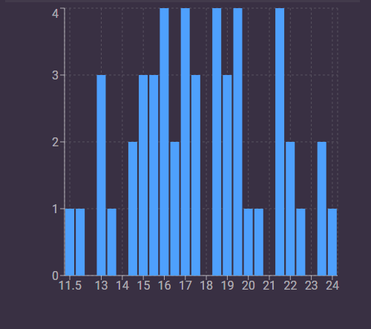

1. Does the histogram appear to be normal? Skewed left? Skewed right? Bimodal?

This histogram appears to be normal, but there seems to be some slight outliers from the 11.5 to 13 points and the 23-24 points.